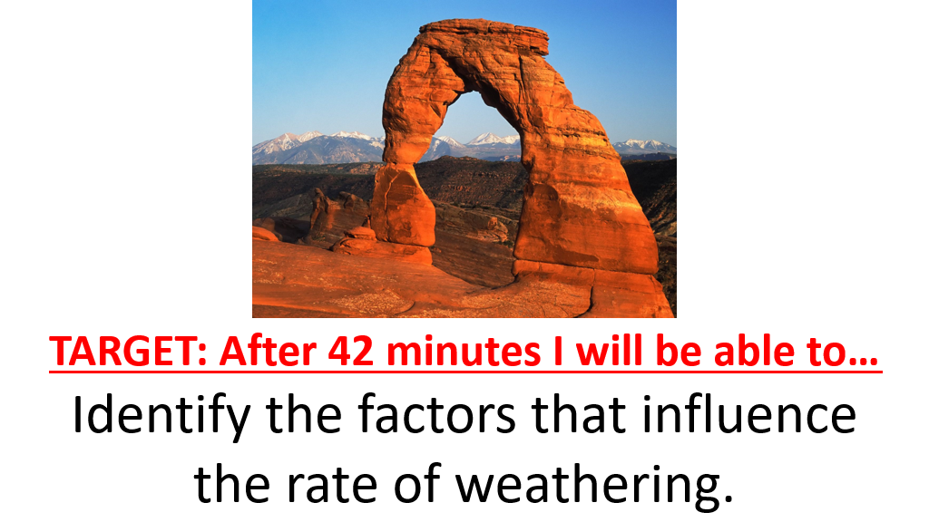
Most weathering processes require…
__________________________
What kind of relationship? ____________________
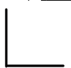
INTRODUCTION QUESTIONS:
1. Which food item can a toddle eat faster, a chicken cutlet or a chicken nugget? Explain why.

2. If a parent wanted to make it easier for the toddler to eat a whole pancake, what could they do to the pancake?

3. People say “Diamonds are forever” but not “Graphite is forever” even though both are made up of the element Carbon. Why?

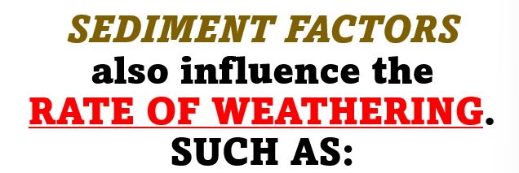
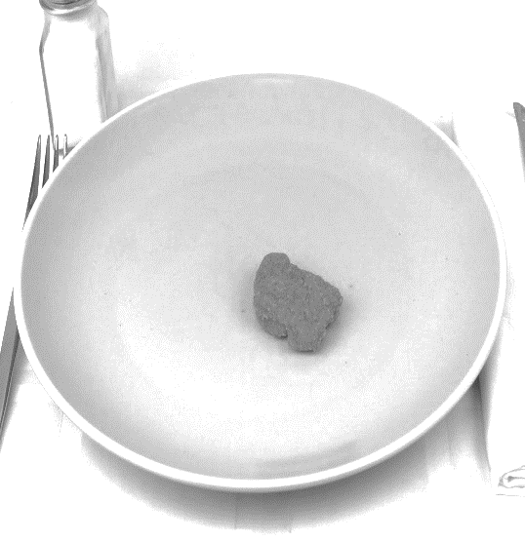
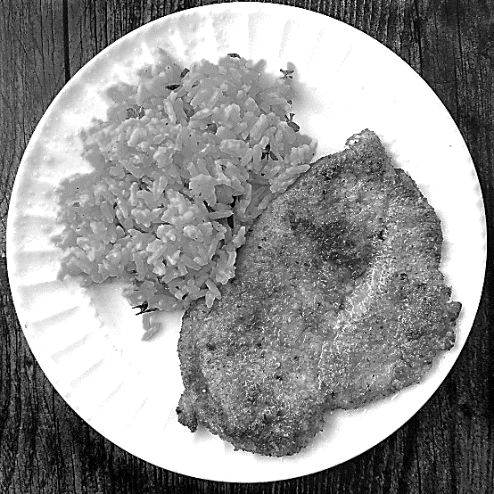
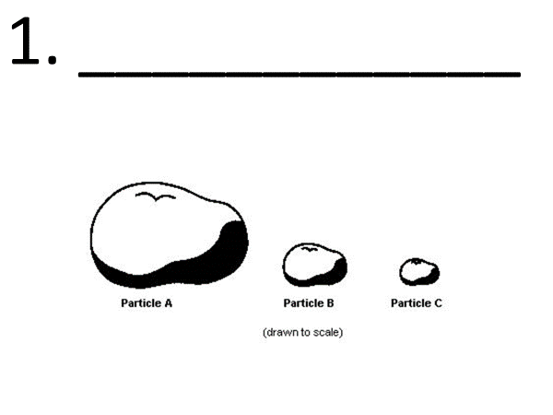
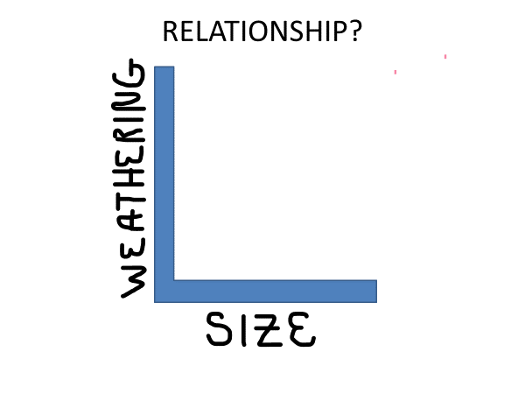
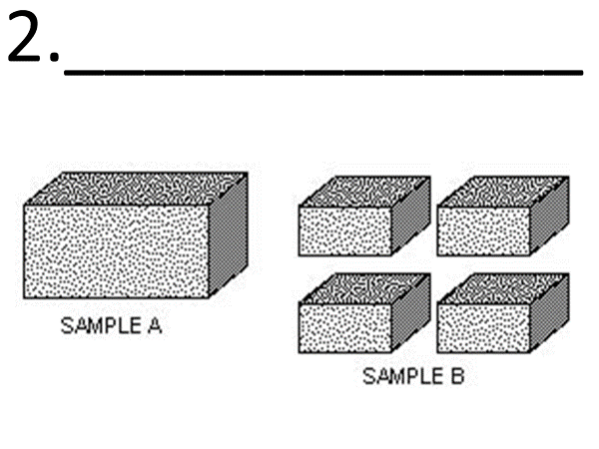

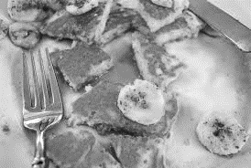

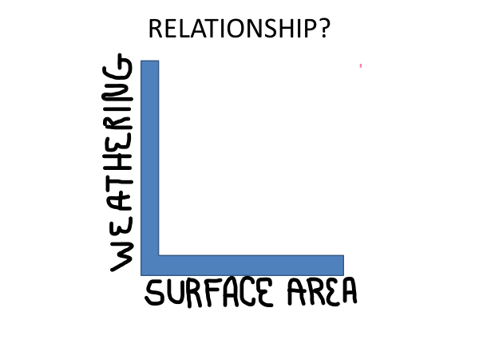
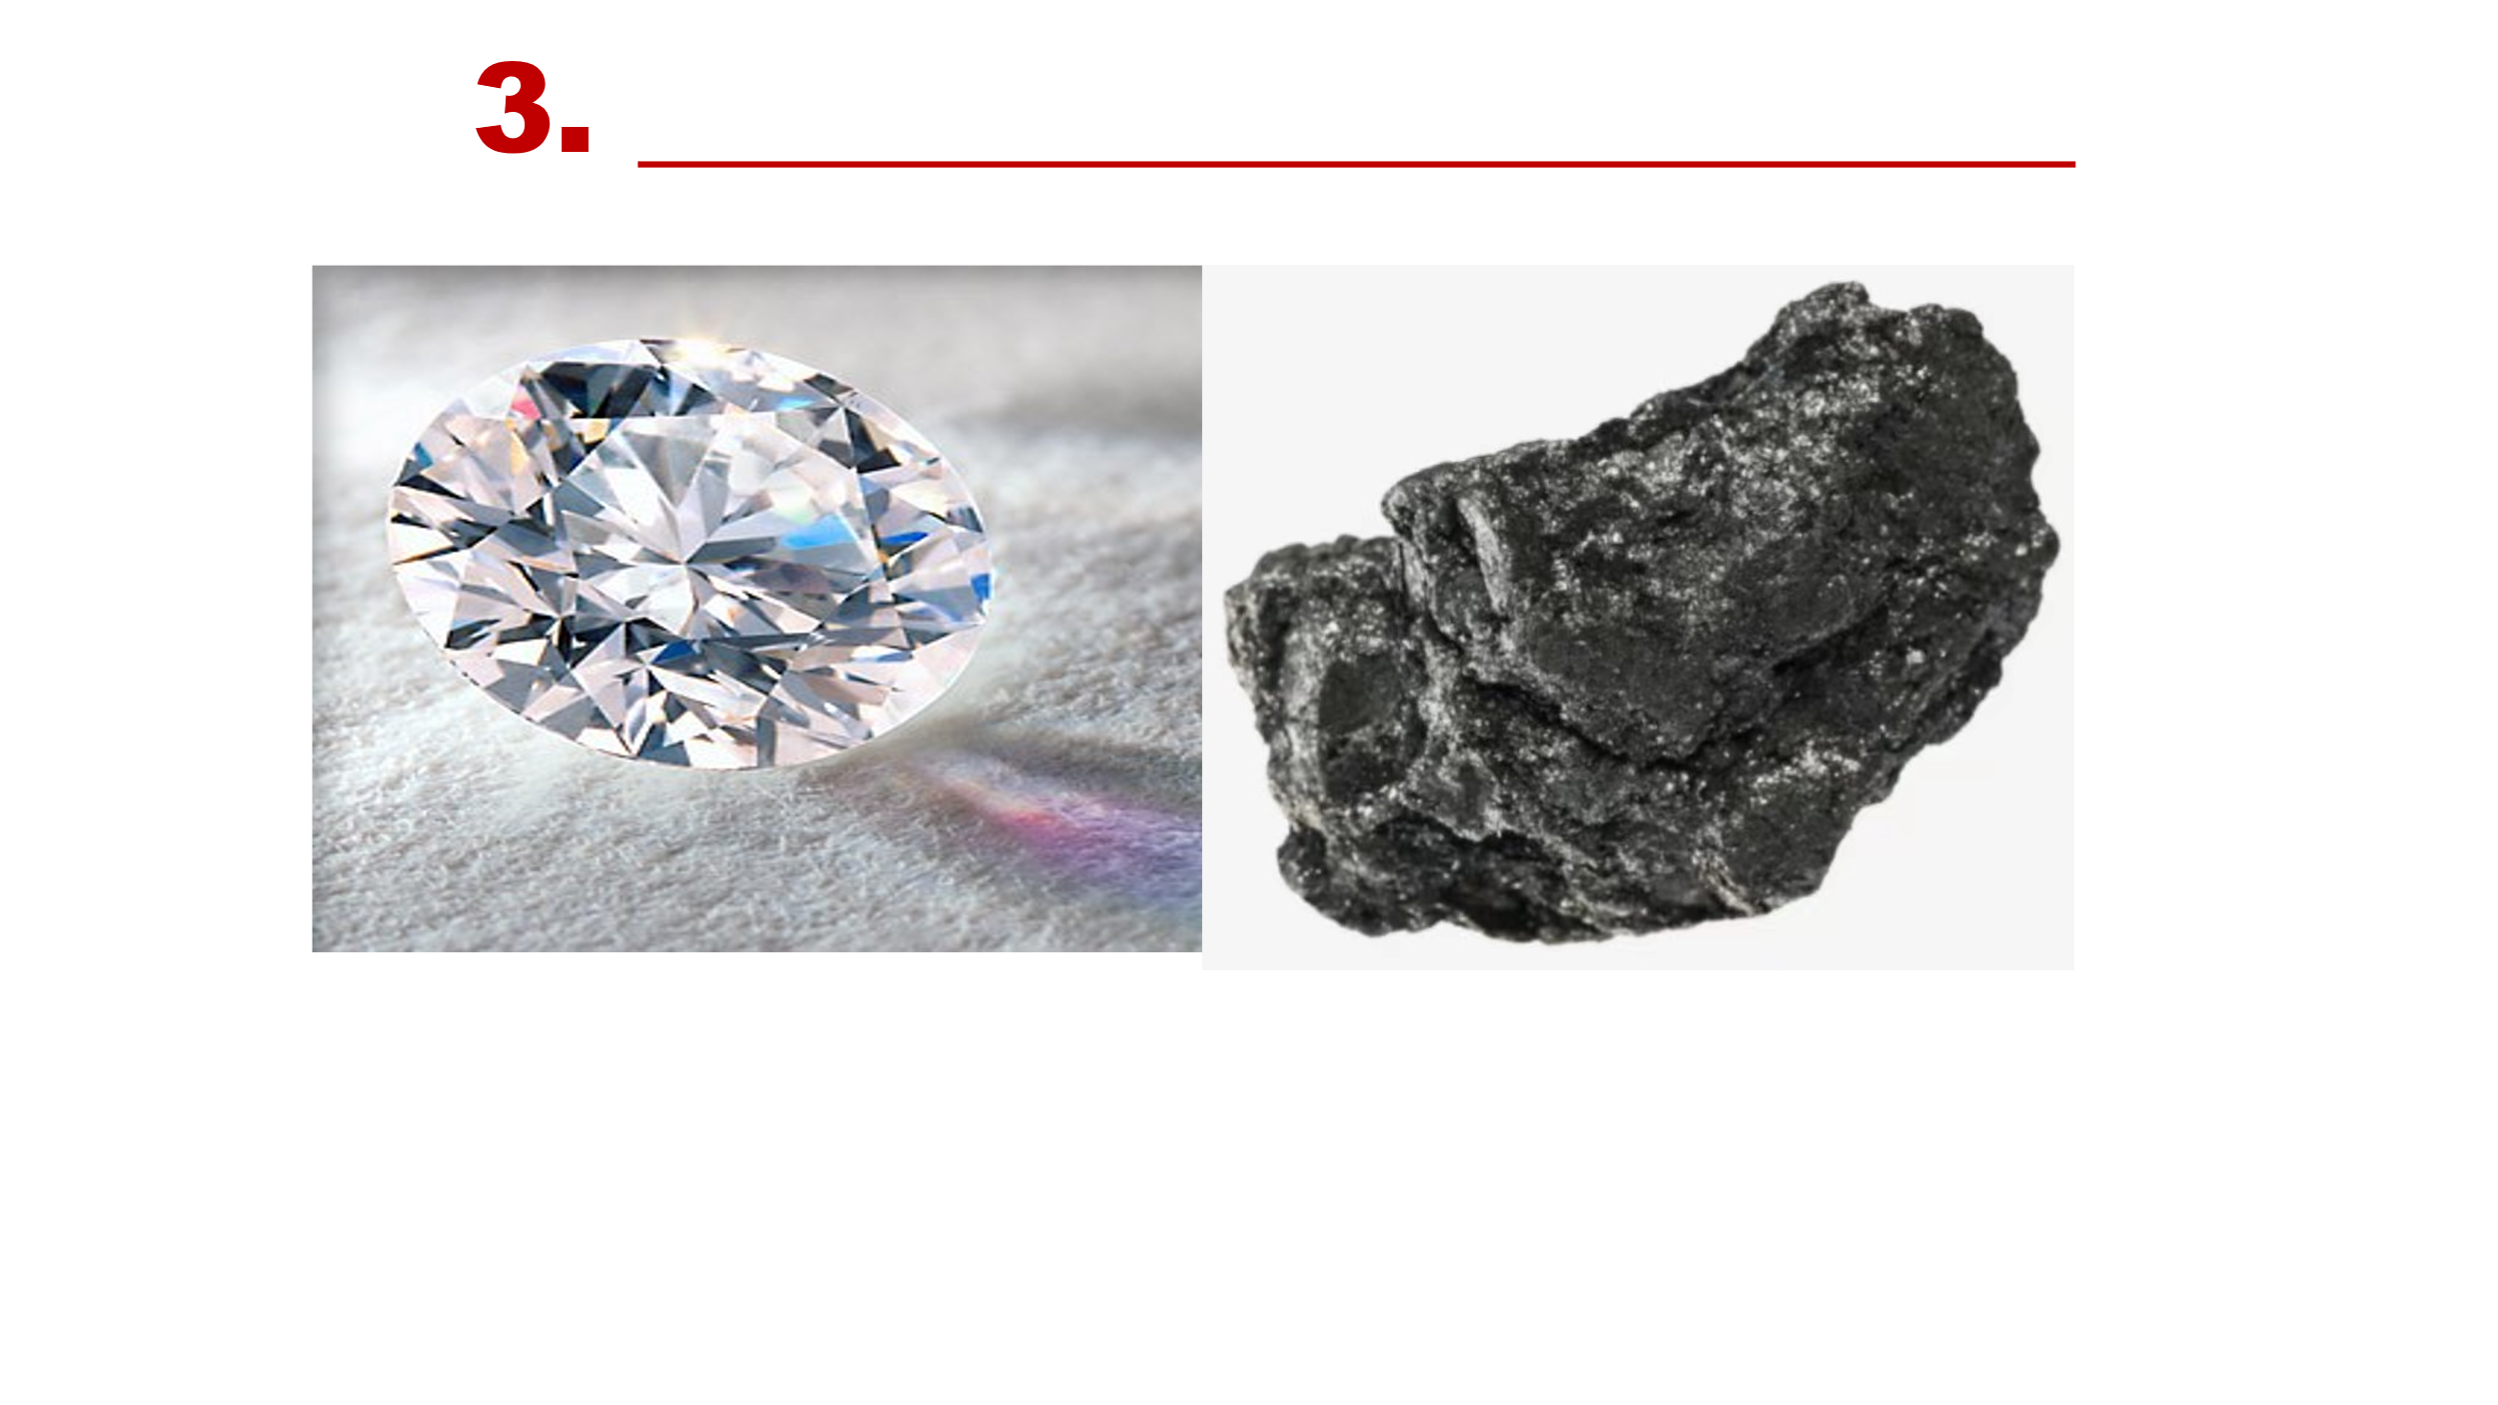
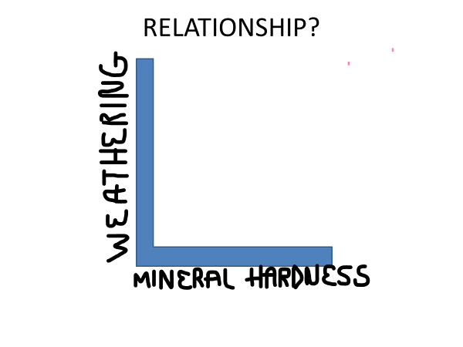
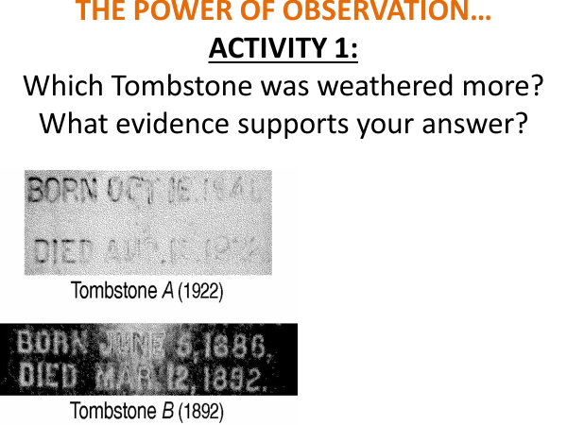
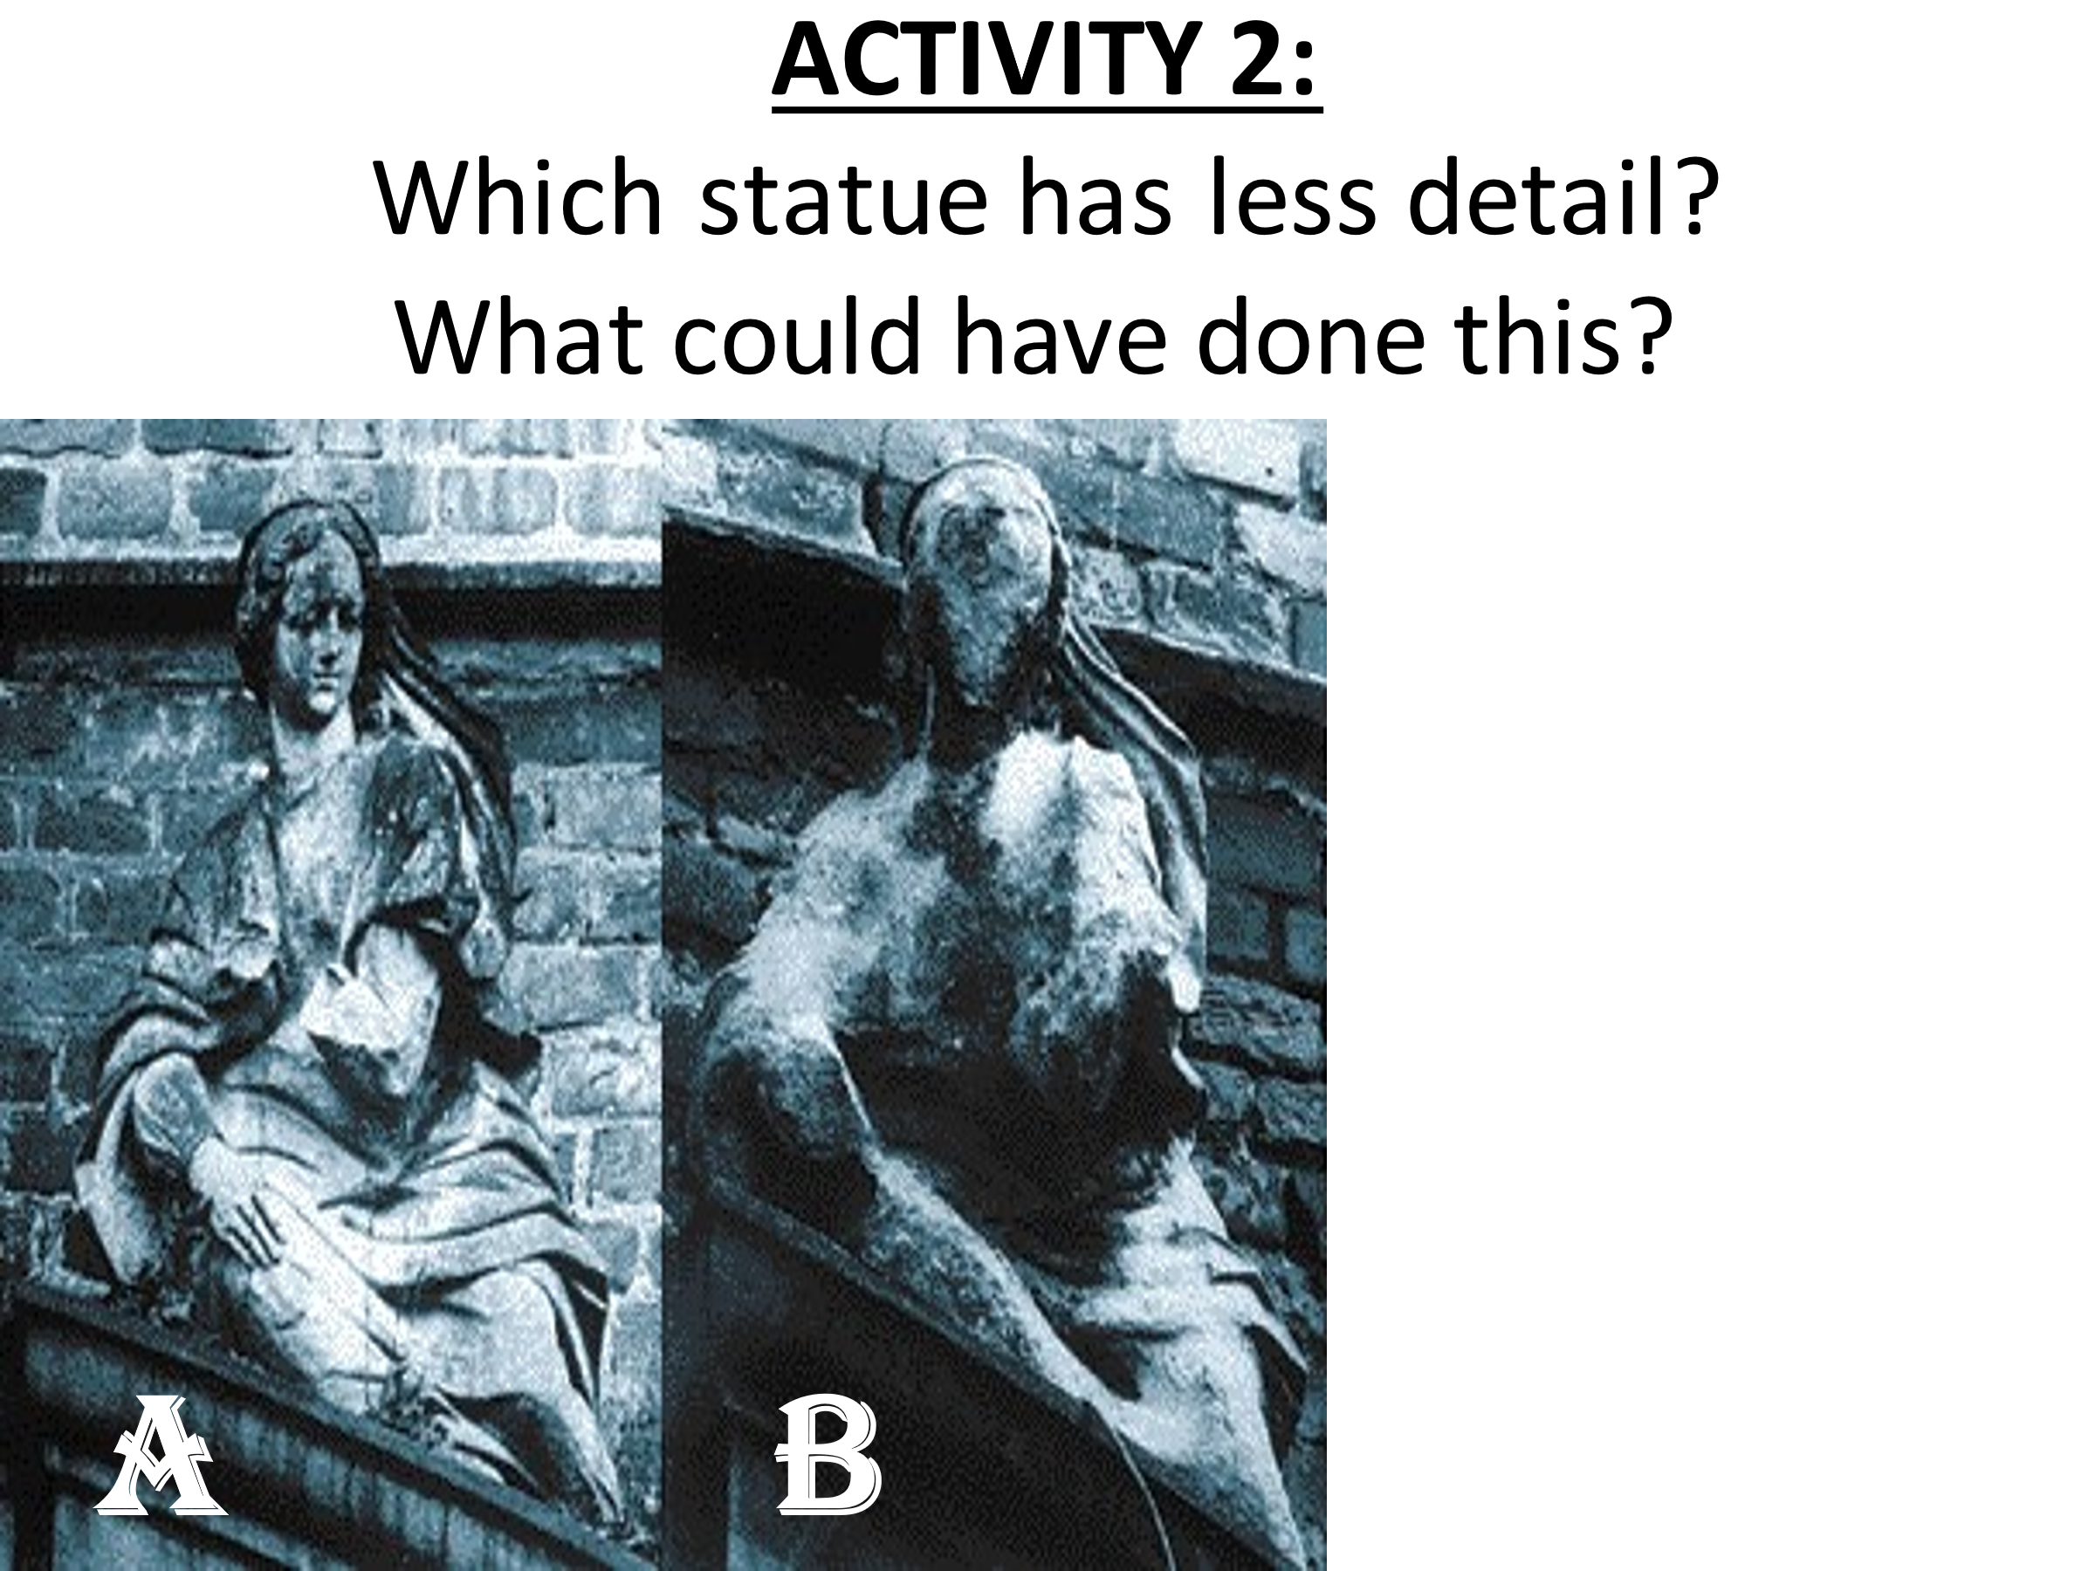
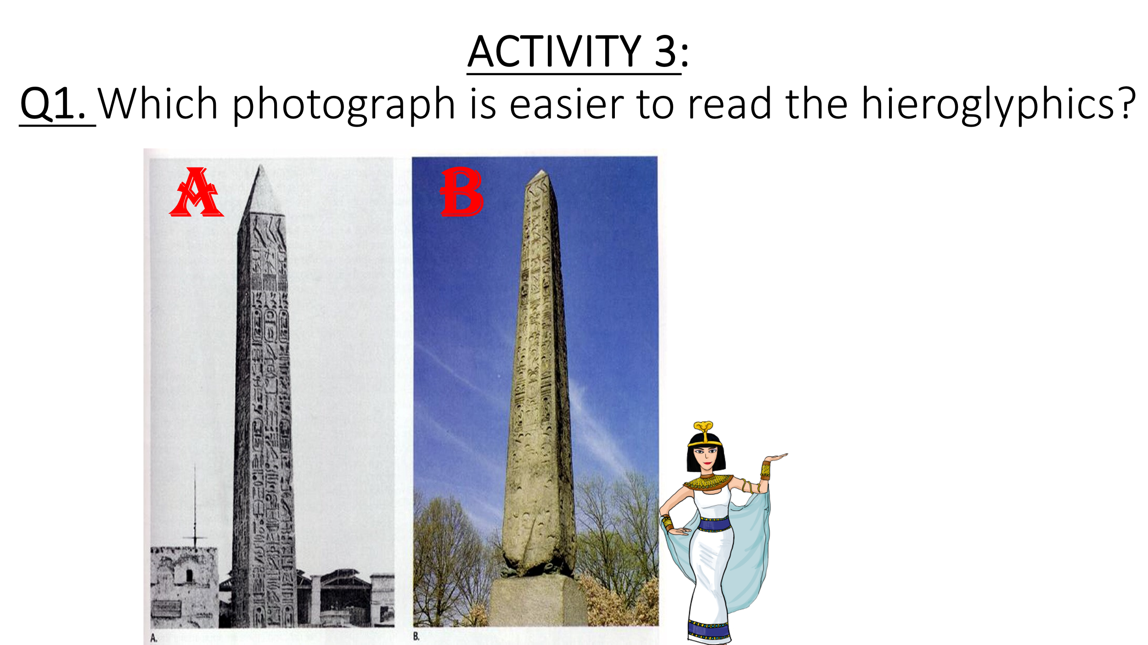

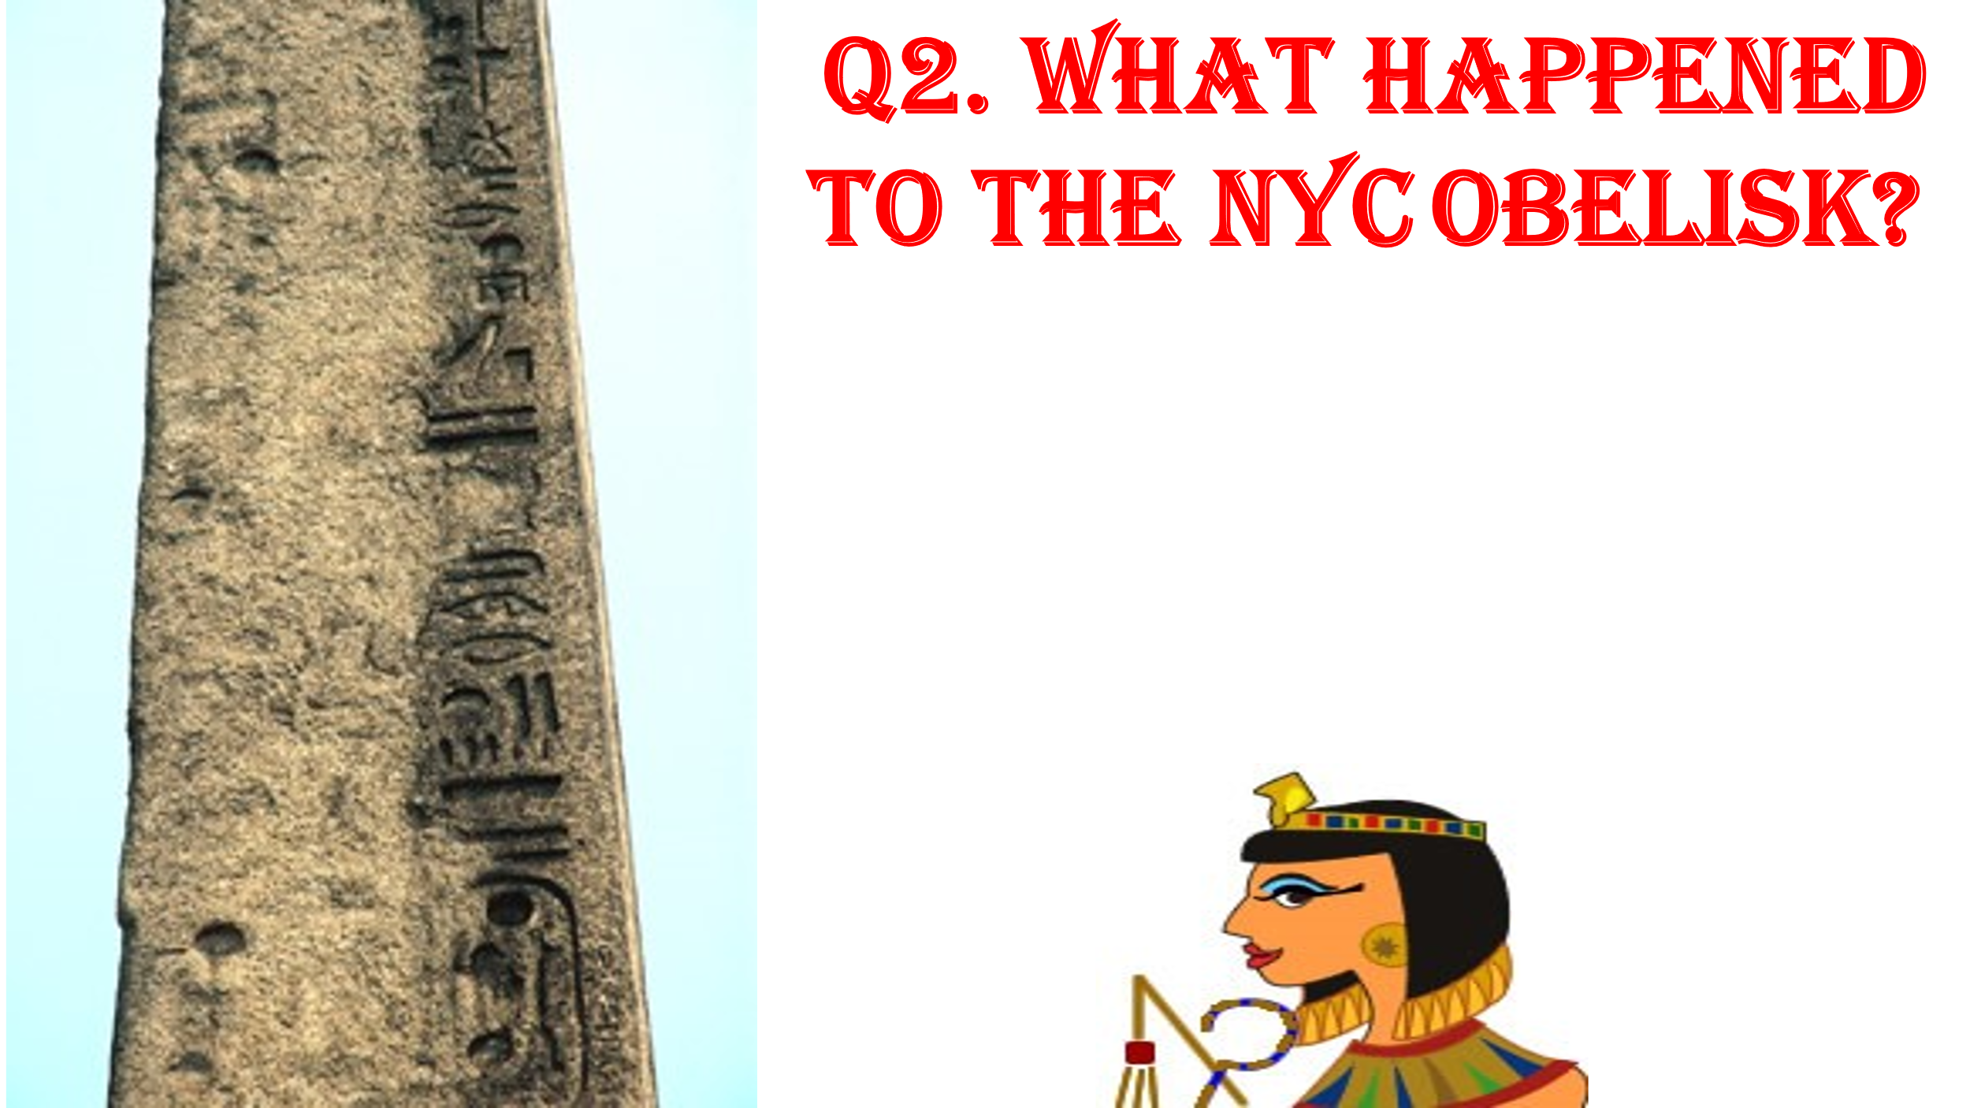
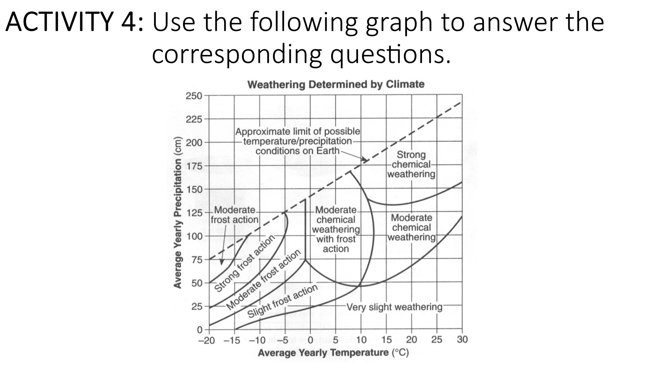
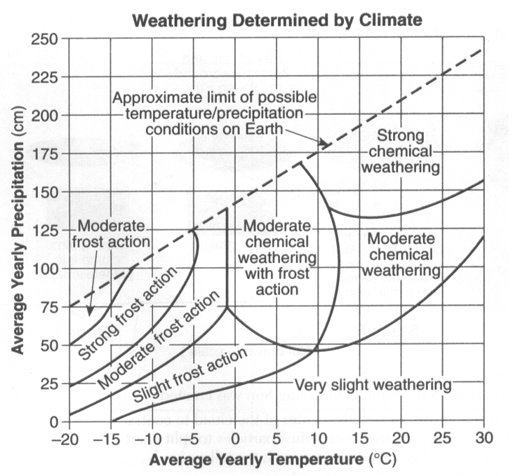
1. Circle your answer. Compared to Physical Weathering, the relative temperature of Chemical Weathering is:
Lower Equal Higher
2. Determine an average yearly precipitation amount that would
cause strong chemical weathering to occur at 25°C:

3. What type of weathering occurs at the following:
- 25°C, 125 cm _______________________________
b. -3°C, 40 cm _______________________________
c. 6°C, 82 cm _______________________________

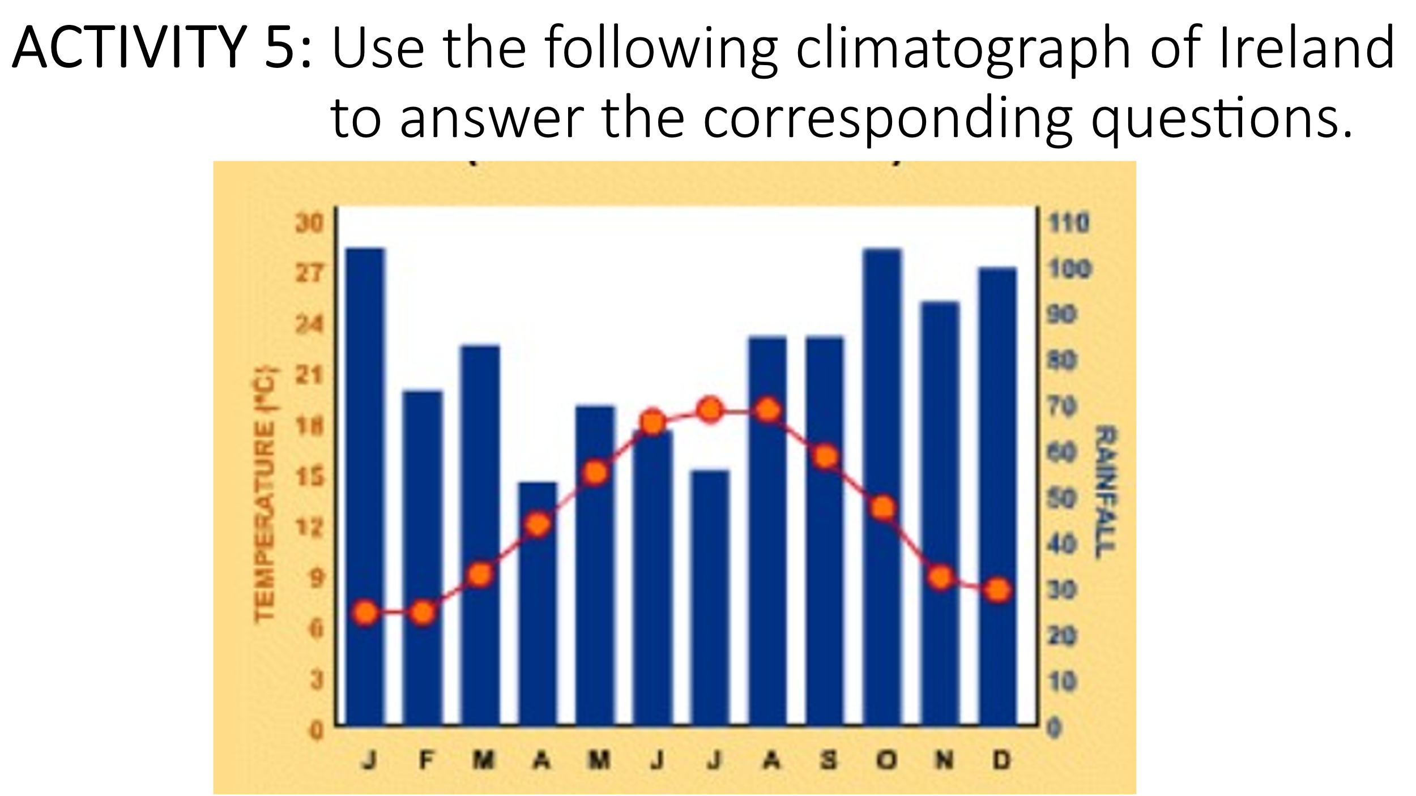
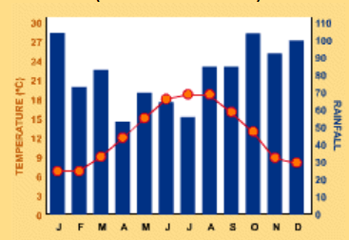

- Which month do you think will have the fastest rate of chemical weathering?

- Explain the reason(s) that you selected this month for question 1.

- Which month do you think will have the most Frost Action?

4. Explain the reason(s) that you selected this month for question 3

